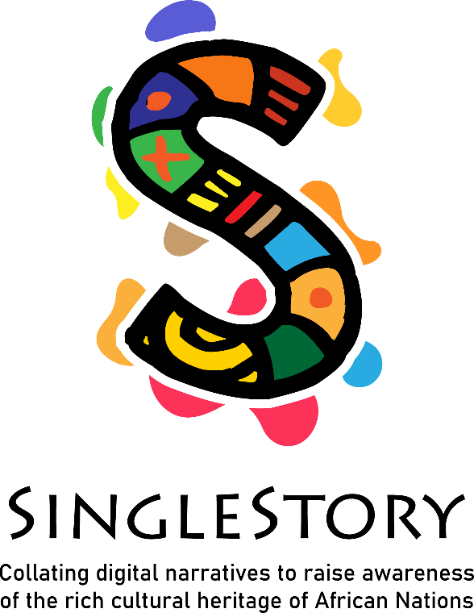

Contents

SingleStory - Induction Training Programme for Community and Adult Educators 3

Module 1 “Storytelling Circles and Africa Heritage” 3

**Face-to-Face/Blended Content** 4

Module 1: Tutor’s Handbook with Lesson Plan 4

1.1 Activity Handout (Face-to-face) 7

Document Revision History

| No. | Document release | Revision date | Revision description | Revision tracking notes |
| --- | --- | --- | --- | --- |
| 1 |  |  |  |  |
| 2 |  |  |  |  |
| 3 |  |  |  |  |

# SingleStory - Induction Training Programme for Community and Adult Educators

## Module 2 “Me as a storyteller”

The Induction Training Programme for Adult and Community Educator (IO2) is structured in 3 modules addressed to:

1. Facilitating storytelling circles
2. **Working in a multicultural environment**
3. Developing the digital skills of educators

This module comprises a face-to-face component of 2 Learning Units, for 3.5 hour lesson plan with correspond activities, and 7 hours of sel-directed learning workshop introducing storytelling techniques, features of African storytelling and supporting educators to facilitate storytelling circles.

# **Face-to-Face/Blended Content**

## Module 2: Tutor’s Handbook with Lesson Plan

| **Module title** | **Working in a multicultural environment** | | | | |
| --- | --- | --- | --- | --- | --- |
| **Target group** | **Adult trainers and intercultural mediators** | | | | |
| **Purpose of this module** | The second module focuses on the Digital Storytelling Curriculum, and specifically on the second module of the Programme as it represents the content of the methodological and argumentative component of SinglStory educational path, which will subsequently be joined by the other component, relating to digital skills. | | | | |
| **Learning outcomes** | Upon completion of this lesson, the learner will be able to:  **Knowledge**   * Know more about different narrative styles in African cultures * Know the theoretical basis of multiculturalism * Know the basics of the body language of the cultures you are working with * Understand the value of dialogue between different cultures.   **Skills**   * Recognise how storytelling can share a sense of history, values, and traditions * Explore the art and techniques of storytelling in different African cultures and practical knowledge of how to use tenses in storytelling for different impacts – past, present and future * Design and apply self-reflection and self-assessment methods to evaluate learning progress.   **Attitudes**   * Willingness to tell stories to promote intercultural understanding and communication * Appreciation of the importance of telling stories and learning new traditions from different cultures * Appreciation of similarities and diversities, fundamental basis for an open dialogue. * Appreciation of an individual’s role in storytelling and preserving traditions | | | | |
| **Module duration** | 3.5 hours | | | | |
| **Topics** | * how to work in a multicultural environment: techniques and exchange of experiences * how storytelling can share a sense of history, values, and traditions in a multicultural perspective | | | | |
| **Preparation** | Participants are strongly advised to visit the project website and follow the Facebook page. | | | | |
| **The Lesson Plan for F2F/Synchronous Learning** | | | | |
| **Topics and Sub-topics/Learning Activities** | | **Duration**  **(minutes)** | **Training Methods** | **Materials/ Equipment Required** |
| Opening of the workshop  The trainer welcomes the participants and proposes the following activity.  Participants are asked to move from their seats and walk around the room until the facilitator says the word: "Stop!".  At this point each participant introduces himself to the closest partner.resentations.  At the end of the presentations the participants return to their seats and the facilitator will ask each participant to introduce to the class their colleague whose presentation they listened to.  It is important that in the presentations the participants also tell about their experience in multicultural environments | | **30** | Icebreaking in plenary | Flipchart and markers  Laptop/Smartphone  Internet |
| Activity 1: How to build a Storytelling  The tutor explains the 4P’s of Story Telling   * People * Place * Purpose * Plot   These points are analyzed by the facilitator from a multicultural perspective  At the end the facilitator asks the participants to split into pairs and exchange views on the 4p's. This tutorial lasts 15 minutes (15’)  The facilitator asks the question: *How to create a story?*  Participants have 15 minutes (15’) to write an answer to this question  Each participant illustrates their definitions in the plenary, having written them on a large sheet of the flip chart.  At the end of the presentations, participants are asked to vote on the two definitions they deem most appropriate (each participant will have three stickers to use to turn over their preferences). | | **60** | Plenary | Flipchart and markers |
| Break | | **15** |
| Activity 2: The power of story telling  The tutor explains the cardinal principles of storytelling:  - Head  - Heart  - Presence  Than the facilitator invites the participants to identify the different interpretation of the tone of voice in different cultures and to discuss in plenary (30’)  At the end of the discussion the facilitator collects all the most relevant inputs on a blackboard by writing them on cards of different colors  As a final exercise, the facilitator invites the participants to work in pairs and to simulate a mediation activity of a discussion about the importance of stories in different cultures. | | **60** | Work in pairs | Flipchart and markers for each group  Internet  Laptop/Smartphone |
| Break | | **15** |
| Closing of the workshop  The trainer retraces the Singlestory project in its overall perspective, seeing the Project website and the Facebook page together, and analyzing the In-Service Training Programme in order to successfully apply the available resources.  To conclude module 2, the trainer proposes a short brainstorming with some overall assessment questions, such as:   * How do you evaluate the application of storytelling practice in adult education? * Do the project website and Facebook page reflect the aims of SingleStory? * The resources analysed in this second module related to the Digital Storytelling Curriculum (module 3) for which final learners are they appropriate? * Who are the potential final beneficiaries in your specific educational context? | | **30** | Presentation  Brainstorming in plenary | Flipchart and markers  Laptop  Proiector |
| **Training Material for F2F Learning** | <https://singlestoryproject.eu/> | | | |
| **Sources** | <https://singlestoryproject.eu/> | | | |

## 1.1 Activity Handout (Face-to-face)

| **Module title** | **Working in a multicultural environment** | | |
| --- | --- | --- | --- |
| **Activity title** | **How to build a Storytelling** | **Activity number** | *2.1* |
| **Description of the activity** | To implement this activity, please follow these steps:  **Step 1** – Participants have to listen the 4P’s of Story Telling  **Step 2** -. Participants have to split into pairs and exchange views on the 4p's  **Step 3** –. Each participant illustrates their answers to the question *How to create a story?*  **Step 4** – Participants vote on the two definitions they deem most appropriate  . | | |

| **Module title** | **Working in a multicultural environment** | | |
| --- | --- | --- | --- |
| **Activity title** | **The power of storytelling** | **Activity number** | *2.2* |
| **Description of the activity** | To implement this activity, please follow these steps:  **Step 1** – Participants have to identify the different interpretation of the tone of voice in different cultures  **Step 2** -. Participants discuss in plenary the issue of "tone of voice" in the different cultures analyzed  **Step 3** –. Participants work in pairs and simulate a mediation activity of a discussion about the importance of stories in different cultures | | |

