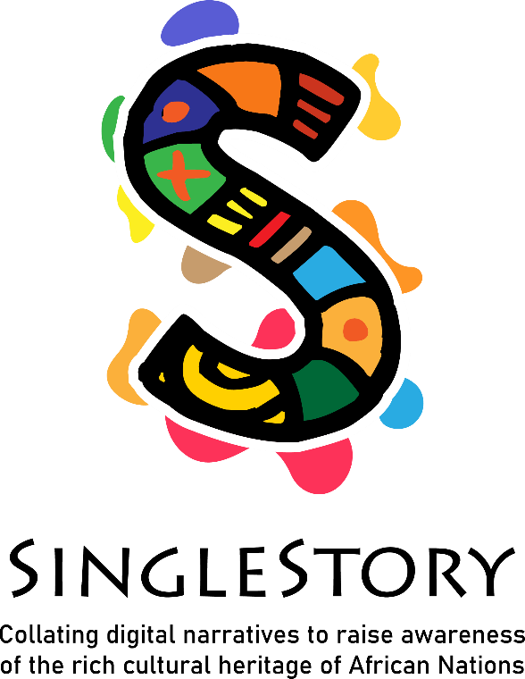

IO2 – In-service Training

Module 1 “Storytelling Circles and African Heritage”

Contents

SingleStory - Induction Training Programme for Community and Adult Educators 3

Module 1 “Storytelling Circles and Africa Heritage” 3

**Face-to-Face/Blended Content** 4

Module 1: Tutor’s Handbook with Lesson Plan 4

1.1 Activity Handout (Face-to-face) 7

Document Revision History

|  |  |  |  |  |
| --- | --- | --- | --- | --- |
| No. | Document release | Revision date | Revision description | Revision tracking notes |
| 1 |  |  |  |  |
| 2 |  |  |  |  |
| 3 |  |  |  |  |

# SingleStory - Induction Training Programme for Community and Adult Educators

## Module 1 “Storytelling Circles and Africa Heritage”

The Induction Training Programme for Adult and Community Educator (IO2) is structured in 3 modules addressed to:

1. **Facilitating storytelling circles**
2. Working in a multicultural environment
3. Developing the digital skills of educators

This module comprises a face-to-face component of 2 Learning Units, for 3.5 hour lesson plan with correspond activities, and 7 hours of sel-directed learning workshop introducing storytelling techniques, features of African storytelling and supporting educators to facilitate storytelling circles.

# **Face-to-Face/Blended Content**

## Module 1: Tutor’s Handbook with Lesson Plan

|  |  |  |  |  |  |
| --- | --- | --- | --- | --- | --- |
| **Module title** | **Storytelling Circles and African Heritage** | | | | |
| **Target group** | **Adult trainers and intercultural mediators** | | | | |
| **Purpose of this module** | The first module focuses on the Digital Storytelling Curriculum, and specifically on the first module of the Programme as it represents the content of the methodological and argumentative component of SinglStory educational path, which will subsequently be joined by the other component, relating to digital skills. | | | | |
| **Learning outcomes** | Upon completion of this lesson, the learner will be able to:  **Knowledge**   * Know more about African storytelling traditions as intangible cultural heritage. * Make connections between the story told by Africans and that told by Europeans. * Describe the traditional and the new techniques to support the cultural expression of African people in Europe through SingleStory storytelling. * Understand the value of dialogue between different cultures.   **Skills**   * Practice African storytelling using traditional performance techniques. * Contextualize and situate the SingleStory training offer to one's own teaching or social work environment. * Design and apply self-reflection and self-assessment methods to evaluate learning progress.   **Attitudes**   * Openness to new and engaging learning methods (face-to-face and online) for fostering inclusive lifelong learning opportunities. * Willingness to face the social challenges of inclusive and respectful communities. * Appreciation of similarities and diversities, fundamental basis for an open dialogue. * Be aware that it is also affecting the learning of a competence considered by the EU among the 8 key competences, cultural and artistic expression. | | | | |
| **Module duration** | 3.5 hours | | | | |
| **Topics** | * Oral history and storytelling: traditional and new forms of transmitting stories in Africa and in Europe * Intercultural relationships in the current society in Europe, considering the regional differencies | | | | |
| **Preparation** | Participants are strongly advised to visit the project website and follow the Facebook page. | | | | |
| **The Lesson Plan for F2F/Synchronous Learning** | | | | |
| **Topics and Sub-topics/Learning Activities** | | **Duration**  **(minutes)** | **Training Methods** | **Materials/ Equipment Required** |
| Opening of the workshop  The trainer welcomes the participants and proposes the following activity for mutual presentations.  Everyone is invited to access the site:  <https://babynames.net/all/african>  Among the many names present, everyone will choose their own new African name, and the meaning will be noted.  The trainer will draw lots for a letter of the alphabet, and those with the name starting with that letter will present themselves with the new African name chosen, which they will write on a flipchart sheet, alongside their real name, and verbally motivate to the group the choice.  At the end of the round of presentations, if there is some time left, the participants are asked for a word that summarizes storytelling as an educational practice.  At the end of the presentation, everyone will be able to take a picture of the names of all the participants, associating them more easily with the new African name. | | **30** | Icebreaking in plenary | Flipchart and markers  Laptop/Smartphone  Internet |
| Activity 1: Definitions  The tutor asks to form pairs to answer the following questions:   * What is storytelling? * What peculiarities does African Storytellin have?   Each couple has fifteen minutes (15’) to formulate the best definition they would use in a classroom of other educators or social workers to introduce SingleStory resources.  Each couple illustrates their definitions in the plenary, having written them on a large sheet of the flip chart.  At the end of the presentations, participants are asked to vote on the two definitions they deem most appropriate (each participant will have three stickers to use to turn over their preferences). | | **60** | Work in pair  Plenary | Flipchart and markers for each couple |
| Break | | **15** |
| Activity 2: African stories and the Griot  The participants, divided into teams of 3-4 people, are invited to create a story, according to the African format (see Activity Sheet 1.1).  As a first element they will have to decide the purpose of the story (entertainment, information, education).  The second element to consider in African history concerns the values to be transmitted.  The third element to include in your story is an African proverb, which you can search for on the internet.  Each group will have 30 minutes to elaborate their African history, and 10 minutes per group to illustrate the result of their team work to the plenary as a Griot. | | **60** | Team-work | Flipchart and markers for each group  Internet  Laptop/Smartphone |
| Break | | **15** |
| Closing of the workshop  The trainer retraces the Singlestory project in its overall perspective, seeing the Project website and the Facebook page together, and analyzing the In-Service Training Programme in order to successfully apply the available resources.  To conclude module 1, the trainer proposes a short brainstorming with some overall assessment questions, such as:   * How do you evaluate the application of storytelling practice in adult education? * Do the project website and Facebook page reflect the aims of SingleStory? * The resources analysed in this first module related to the Digital Storytelling Curriculum (module 1) for which final learners are they appropriate? * Who are the potential final beneficiaries in your specific educational context? | | **30** | Presentation  Brainstorming in plenary | Flipchart and markers  Laptop  Proiector |
| **Training Material for F2F Learning** | <https://singlestoryproject.eu/> | | | |
| **Sources** | <https://singlestoryproject.eu/> | | | |

## 1.1 Activity Handout (Face-to-face)

|  |  |  |  |
| --- | --- | --- | --- |
| **Module title** | **Storytelling Circles and African Heritage** | | |
| **Activity title** | **African stories and the Griot** | **Activity number** | *1.1* |
| **Description of the activity** | To implement this activity, please follow these steps:  **Step 1** - Go to the SingleStory MOOC and access Module 1 of the Digital Storytelling Curriculum, and have a quick review of the resources.  **Step 2** - Decide the purpose of the story (entertainment, information, education) and start the script of your story.  **Step 3** – Decide the values to be transmitted. Obviously at this stage you have to let your imagination and creativity help you, but that it is connected to Africa and its stories.  **Step 4** – Search fo an African proverb, and included it in your story.  For these first four steps you have 30 minutes.  **Step 5** – Each member of the group is asked to play a part of the script, like a Griot to show and tell their story to the other participants.  For your presentation you have 10 minutes. | | |

