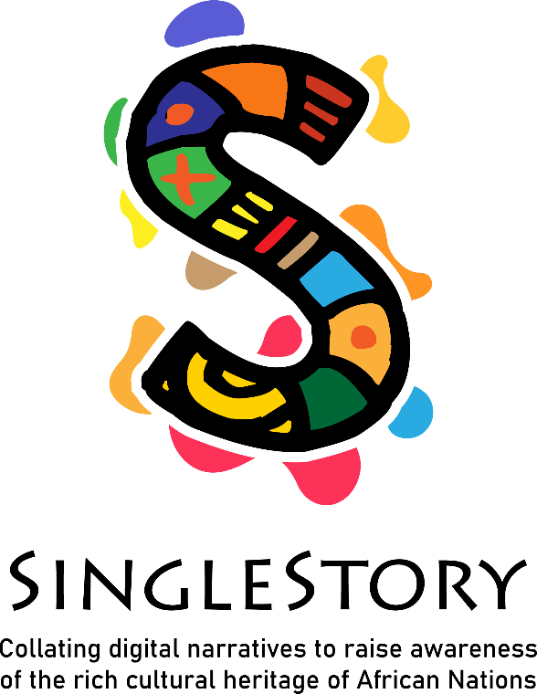
IO2 – Induction Training Programme
Self-directed learning
Working in a multicultural environment

IO2 – Induction training programme

Working in a multicultural environment

The aim of the module is to improve learners' knowledge of writing stories. After completing the module, the adult learners will know how to write a story and what techniques needed to develop them. They will improve their literacy and writing skills as well as the techniques of a storyteller.

Improve learners' knowledge of writing stories.
Know how to write a story and what techniques needed to develop them.
Improve their literacy and writing skills and the techniques of a storyteller.

Module Title: | IO2 – INDUCTION TRAINING- SELF DIRECTED LEARNING
Title of Activity: | Activity 1- How to build a Storytelling  Write the moments  Exercise based on remembering and the transposition of remembering in the present and its extension in the future.  Memory of a moment when one was in contact with a ceremony or a happy or unhappy event.  Immerse yourself in memories, capture a moment and make it an extension in time through writing.  Use the writing codes of tales, dialogues of "African narration": the proverb, humor, repetition, the parable and write a 10-line story.
Duration of Activity: | 1:30
Why use this resource? | - Know more about different narrative styles in African cultures  - Explore the art and techniques of storytelling in different African cultures and practical knowledge of how to use tenses in storytelling for different impacts – past, present, and future
What will you get from using this resource? | Upon completion of this lesson, the learner will be able to understand  how storytelling can share a sense of history, values, and traditions in a multicultural perspective.  The learner will be able to develop creative writing skills (emotions)
Link to Additional Resources or Reading Materials: | TV5MONDE Afrique  Kulu la Tortue et Zé la Panthère : Conte du Cameroun https://www.youtube.com/watch?v=ZJmEyCBillo  A vérifier, compléter, adapter
References/ Sources: | Singlestory MOOC  Moduel 2 – Me as a storyteller

Module Title: | IO2 – INDUCTION TRAINING- SELF DIRECTED LEARNING
Title of Activity: | Activity 2- How to build a Storytelling  Bringing words to life  It is a question of choosing a list of 10 words and from these 10 words formulating a tale, a nursery rhyme, a text, or a poem.  Here we will highlight the participant's ability to tap into their imagination, to go beyond the first meaning of the word to bring it to life in a story...  The participant must use the 10 words
Duration of Activity: | 1:30
Why use this resource? | - Know the theoretical basis of multiculturalism  - Recognise how storytelling can share a sense of history, values, and traditions  - Explore the art and techniques of storytelling in different African cultures and practical knowledge of how to use tenses in storytelling for different impacts – past, present and future  - Willingness to tell stories to promote intercultural understanding and communication
What will you get from using this resource? | Upon completion of this lesson, the learner will be able to:  develop creative writing skills allowing participants to use their imaginations, bring memories to life, update and/or revive stories of yesteryear. Share moments of life and write them down.
Link to Additional Resources or Reading Materials: | Générateur de mots aléatoires en français  https://www.palabrasaleatorias.com/mots-aleatoires.php?fs=10&fs2=0&Submit=Nouveau+mot  TROUVER GENERATEUR MOTS ENANGLAIS
References/ Sources: | Singlestory MOOC  Moduel 2 – Me as a storyteller

Module Title: | IO2 – INDUCTION TRAINING- SELF DIRECTED LEARNING
Title of Activity: | Activity 3- The power of storytelling  A RELIRE – FINALISER OU MODIFIER  Entre mots  Le personnage participe à une cérémonie de mariage / repas chez des amis issus d’une culture différente. (Trouver lien fête ou cérémonie d’un pays )  Le but ici est de faire vivre aux lecteurs deux approches différentes d’une situation commune.  Le personnage nous racontera l’évènement avec une approche européenne puis avec l’approche de la culture ici choisie.  Relever 3 expressions, phrases relevant des traditions et coutumes de chaque culture.  Expliquer les différents codes ou les codes similaires utiliser dans chaque culture.
Duration of Activity: | 1:30
Why use this resource? | Know the basics of the body language of the cultures you are working with  Willingness to tell stories to promote intercultural understanding and communication
What will you get from using this resource? | Upon completion of this lesson, the learner will be able to understand the impact that culture has on our daily interaction and promotes intercultural understanding and communication.
Link to Additional Resources or Reading Materials: | A Trouver  Vidéo
References/ Sources: | Singlestory MOOC  Moduel 2 – Me as a storyteller

Module Title: | IO2 – INDUCTION TRAINING- SELF DIRECTED LEARNING
Title of Activity: | Activity 4  The power of storytelling  A REVOIR – FINALISER OU MODIFIER  If I had to tell you  Use techniques and codes drawn from African and European narration and literature to tell the other.  Write a rhyme (comptine) 10 lignes
Duration of Activity: | 1:30
Why use this resource? | - Understand the value of dialogue between different cultures.  - Appreciation of similarities and diversities, fundamental basis for an open dialogue.  - Appreciation of an individual’s role in storytelling and preserving traditions
What will you get from using this resource? | Upon completion of this lesson, the learner will be able to understand the impact that culture has on our daily interaction and promotes intercultural understanding and communication.
Link to Additional Resources or Reading Materials: | A trouver  Articles/documents en ligne + activités de suivi  EXEMPLE COMPTINE EUROPE ET AFRIQUE
References/ Sources: | Singlestory MOOC  Module 2 – Me as a storyteller

Module Title: | IO2 – INDUCTION TRAINING- SELF DIRECTED LEARNING
Title of Activity: | Activity 5  Working in a multicultural environment  Reflexion : A REVOIR – MODIFIER - FINALISER  Qu’avez-vous appris de nouveau dans votre écriture ?  Votre imaginaire ne serait-il pas une source d’inspiration pour transcrire et retranscrire une histoire.  La narration africaine vous a-t-elle inspiré pour raconter des histoires contemporaines.  Ces exercices vous ont-ils apporter des éléments sur la communication interculturelle, si oui lesquels ?  Pouvez cous donner en 5 mots pour décrire la narration africaine ?
Duration of Activity: | 1H00
Why use this resource? | Design and apply self-reflection and self-assessment methods to evaluate learning progress
What will you get from using this resource? | Upon completion of this lesson, the learner will be able to:  - Know more about different narrative styles in African cultures  - Understand the value of dialogue between different cultures.  - Willingness to tell stories to promote intercultural understanding and communication  - Appreciation of the importance of telling stories and learning new traditions from different cultures  - Appreciation of similarities and diversities, fundamental basis for an open dialogue.
Link to Additional Resources or Reading Materials: | A Trouver
References/ Sources: | Singlestory MOOC  Module 2 – Me as a storyteller

