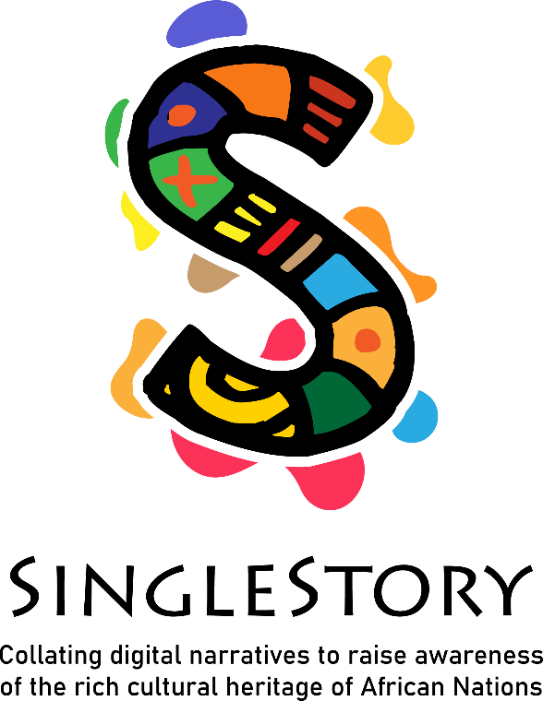
IO2 – Induction Training Programme
Self-directed learning
Facilitating storytelling circles

IO1 – Induction Training Programme

Facilitating storytelling circles

Aim of the module: This aim of this module is to provide participants with an introduction to African storytelling, African stories and the role of the Griot in African culture.

introducing storytelling techniques,
features of African storytelling,
supporting educators to facilitate storytelling circles.

Module Title: | IO2 – INDUCTION TRAINING- SELF DIRECTED LEARNING
Title of Activity: | Activity 1  CONTES TOI - Writing  “TELL YOURSELF”  The storyteller is a key figure in the chiefdoms, a key figure in the transmission of ancestral knowledge.  For the learner, it is a question of writing, describing, and bringing to life the griot who is in him through his text.  The goal here is to use and integrate storytelling skills related to the character of the griot itself:  Transmission of a message by  Using African proverbs, parables, popular expressions  Using repetition  Using humor  Using moral education  The learner will also be led to stage his own text, where the griot will come to life through these writings:  And record a video declaiming or playing his text. (See Module 3)  Video length: 5mn  The educational objective here is to develop the imagination of the learner and to acquire the processes and means of communication resulting from the transmission of knowledge of African societies.
Duration of Activity: | 1:30
Why use this resource? | In this activity the learners we will be able to understand how to transmit knowledge through the tales, the epics on the African kingdoms, on the mythologies of the different tribes, the habits, and customs.
What will you get from using this resource? | The storyteller, by telling himself, allows the other to understand him and to find similarities with him.  Which triggers the possibility of a thousand dialogues.  Upon completion of this lesson, the learner will be able to understand the features of African storytelling,
Link to Additional Resources or Reading Materials: | -Ahmadou Kourouma, un conteur traditionnel sous la peau du romancier  https://journals.openedition.org/semen/1220
References/ Sources: | MOOC IO1 - Module 1  Unit 3 – Activity 1: The Griot  Unit 3 – Activity 2: The role of the Griot  MOOC IO1 - Module 2  MOOC IO1 – Module 3

Module Title: | IO2 – INDUCTION TRAINING- SELF DIRECTED LEARNING
Title of Activity: | Activity 2  ECOUTES BIEN, ECOUTES AVEC TON AME ! -  LISTEN WELL, LISTEN WITH YOUR SOUL! – Writing  Storytelling occupies a very important function in African intangible cultural heritage.  In traditional African matriarchal societies, the place of learning par excellence is the kitchen.  Around the fire where a pot is simmering over low heat, the grandmother, the Mother, the Aunt, the Big Sister, distill advice, epics, cooking recipes.  The medium used here will be a conversation punctuated by parables, rhyme, irony.  This conversation ranges from speech to song, song to dance, and dance to speech again.  The learner will write, describe the conversation between these women, use and integrate African storytelling techniques: Parables, proverbs, thoughts, irony and rhymes, songs.  The educational objective here is to develop the imagination of the learner and to acquire methods and means of communication resulting from the transmission of knowledge of African societies
Duration of Activity: | 1:30
Why use this resource? | With this activity, the learner will be able to use African storytelling techniques: Parables, proverbs, thoughts, irony, rhymes, and songs to convey advice and feelings.
What will you get from using this resource? | Upon completion of this lesson, the learner will be able to use the rhyme, the parable, have the capacity for analysis and criticism, but also pushes the other to perceive the different energies carried by the words and the evils expressed.
Link to Additional Resources or Reading Materials: | La Tradition orale et sa méthodologie – Vansina Jan  https://unesdoc.unesco.org/ark:/48223/pf0000042767_fre
References/ Sources: | MOOC IO1 - Module 2  Unit 1 – Activity 3: Identify yourself with a story

Module Title: | IO2 – INDUCTION TRAINING- SELF DIRECTED LEARNING
Title of Activity: | Activity 3  L’ART DU LIEN ET LE LIEN DE L’ART – (writing)  THE ART OF LINK AND THE LINK OF ART  Readjustment of known stories.  The learner will readapt stories according to different social, geographic, and climatic contexts
Duration of Activity: | 1:30
Why use this resource? | The action proposed here is to better understand the other's environment and to be able to reinforce similarities and create emotional bonds.
What will you get from using this resource? | Upon completion of this lesson, the learner will be able to share the "common". This common which units us each with its differences.  This common prompts us to understand each other, to accept each other's differences and to respect each other.
Link to Additional Resources or Reading Materials: | Le conte entre écriture et réécriture : tradition ou innovation ?  https://gerflint.fr/Base/France7/fatima.pdf
References/ Sources: | MOOC IO1 - Module 1  Unit 2 – Activity 1:

Module Title: | IO2 – INDUCTION TRAINING- SELF DIRECTED LEARNING
Title of Activity: | Activity 4  « JE « DE MOTS - game design - riddle  PLAY WITH WORDS  The learner leads the listener to guess the chosen word.  This is a guessing game.  The learner here uses the technique of improvisation to arouse the questioning of the listener.  To get him to understand through his words; his words become the words of the listener; to arrive at the correct answer.
Duration of Activity: | 1:30
Why use this resource? | The learner should get the listener to guess the chosen word.  This is a guessing game.  The learner here uses the riddle to provoke questioning in the listener, to help him understand through his words. His words become the words of the listener; to arrive at the correct answer.
What will you get from using this resource? | Upon completion of this lesson, the learner will be able to better understand the value of words and their meaning from one another's point of view.
Link to Additional Resources or Reading Materials: | ORAL LITERATURE IN AFRICA - Ruth Finnegan  Riddles and related forms. Style and content. Occasions and uses. Conclusion  https://books.openedition.org/obp/1203?lang=fr#:~:text=3In%20Africa%20riddles%20are,the%20'proverb%2Driddle'.
References/ Sources: | MOOC Module 1  Unit 2 – Activity 1  Unit 2 – Activity 2

Module Title: | IO2 – INDUCTION TRAINING- SELF DIRECTED LEARNING
Title of Activity: | Activity 5  Develop, record, and edit your own story  Take the story written at activity 1: CONTES TOI – “TELL YOURSELF»  Or choose a story from the resources (see reference sources below)  Go to the SingleStory MOOC and access Module 3 of the Digital Storytelling Curriculum, and follow the steps in the resource: Producing your story in a digital format  Record a video of you or the person of your choice reciting or acting out the story or record it in audio.  Video length: 5mn
Duration of Activity: | 1H00
Why use this resource? | - Basic knowledge of how digital storytelling can be used to promote and share stories with the wider community  - Basic knowledge of how stories can be produced as short films, podcasts, animations, interviews, videos, etc.
What will you get from using this resource? | Upon completion of this lesson, the learner will be able to understand the basic knowledge of how stories can be produced as short films, podcasts, animations, interviews, videos, etc.
Link to Additional Resources or Reading Materials:  A COMPLETER MODIFIER SI BESOIN | Youtube : Madestelle1  - La cuillère sale, Birago Diop :  https://youtu.be/XnoDsB4EbuI?t=44  Contes lus par Ariane Mawaffo  Illustration : Jocelyn Kagina / P. Compendium  Montage et réalisation : Cerendi Visuals
References/ Sources: | MOOC - Module 3

